Database Application User Manual

Pathfinder Youth Centre Society

Table of Contents

Logging In 3

Home Screen 4

Navigation Bar 5

Filtering Participants by Status 5

Participants List View 6

Sorting Participants 6

Searching Participants 6

Pagination 7

View Full Participant Information 7

Viewing a participant record 8

Participant Notes 9

Note History 9

Adding a Note 9

Participant History 10

Participant Record Actions – View mode 11

Edit 11

Approve 11

Decline 11

Archive 11

Restore 12

Delete 12

Editing a participant record 12

Participant Record Actions – Edit mode 13

Confirm 13

Cancel 13

Creating a participant record 14

Participant Record Actions – Create mode 15

Confirm 15

Cancel 15

New Applications 16

Processing a New Application 16

Edit 17

Accept and Save 17

Discard Submission 17

Statistics 18

Refreshing Statistics 18

Saving Participant Data Locally 19

Viewing Statistics by Demographic 19

Staff Management 20

User Actions 20

Edit 20

Reset Password 20

Delete 21

User Roles 21

Adding a New User 21

Completing Enrollment 21

Troubleshooting 22

# Logging In

If you have an existing staff user account and you want to log in, navigate to <http://pathfinderyouthsociety.web.app/sign-in>. If you are not already signed in, you will see the following login page:

Enter your email address and password and press sign in or the enter key on your keyboard.

If you forget your password, you must contact your supervisor. They will be able to send you a password reset link.

**Note:** If you don’t have an account, you must have your supervisor create one for you before you can log in. For information on account creation, see *Adding a New User* on page 21.

# Home Screen

Once you are logged in, you will see the following home screen. The default view is the Participants List View.

3

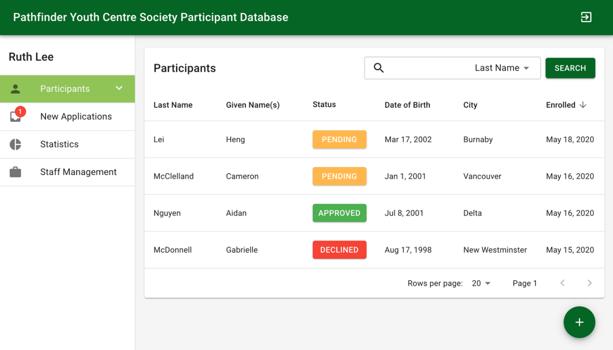

2

1

4

6

5

**Note:** There may be a slight delay before the table populates, as the records are being loaded from the database.

The components are as follows:

1. The name of the current logged-in user
2. Navigation bar
3. Log out button
4. Record search bar
5. Table header and sort fields
6. Add record button

**Note:** If your window is too narrow to display the full page, you won’t see the navigation bar. To open it, click the three lines in the top left corner.

# Navigation Bar

The navigation bar is the central hub for switching views, filtering records by status, and exploring participant information. From here, you have access to the participants list, the new applications list, a statistics view, and, for admin users, a staff user management interface.

**Note:** The “Staff Management” button will only be visible if the current user is an admin.

## Filtering Participants by Status

Participant records can have one of five statuses:

|  |  |
| --- | --- |
|  | A new application that has not yet been saved into the system |
|  | A participant who has started the application process, but who hasn’t yet been approved or declined |
|  | A participant that has been approved to join the program |
|  | A participant whose application has been declined |
|  | An archived record. Archived records do not appear in the main participant view and can be deleted completely from the database. |

To filter participants by status, click on the expand arrow on the participants button in the navigation bar. Click on one of the statuses to filter the table.

|  |  |  |
| --- | --- | --- |
|  |  |  |

# Participants List View

From the participants list view, you can view, sort, and search participant records. By default, the participants list shows Approved, Pending, and Declined participants.

## Sorting Participants

The column the table is currently sorted by is indicated by an arrow. By default, the table is sorted by the most recently created records. To sort by other categories, mouse over the desired column header and an arrow will appear. Clicking on it will sort the table by that column. To change whether the sort is ascending or descending, click on the arrow again.

**Note:** It’s not possible to sort by status. You can filter by status using the sidebar.

## Searching Participants

To search for a specific participant record, use the search bar in the top of the table. The default search is by last name, but you can change the search field by clicking on the arrow in the search box. To clear a search and see the full list again, delete the text in the search box and press Search or the enter key on your keyboard.

**Note:** While using the search function, only the field you’ve selected to search by can be used to sort the results.

## Pagination

You can change the number of records visible per page and navigate between pages using the dropdown and arrows at the bottom of the table.



## View Full Participant Information

When you want to see a participant’s full details, click on their entry in the table.

# Viewing a participant record

When a participant record is opened, this screen appears. Here, you can view, edit, approve, decline, and archive participant records. This screen differs slightly, depending on the status of the record you are viewing.

The side navigation drawer contains a back button that will return the user to the list view and a list of the different sections of the participant record. It also lists two additional sections: one for staff notes and one for participant record history.

1

3

3

4

2

5

The components are as follows:

1. Participant record navigation
2. Participant data
3. Participant record actions
4. Current participant status
5. Back button

## Participant Notes

The notes section contains an interface for staff members to add and view notes about a participant.   
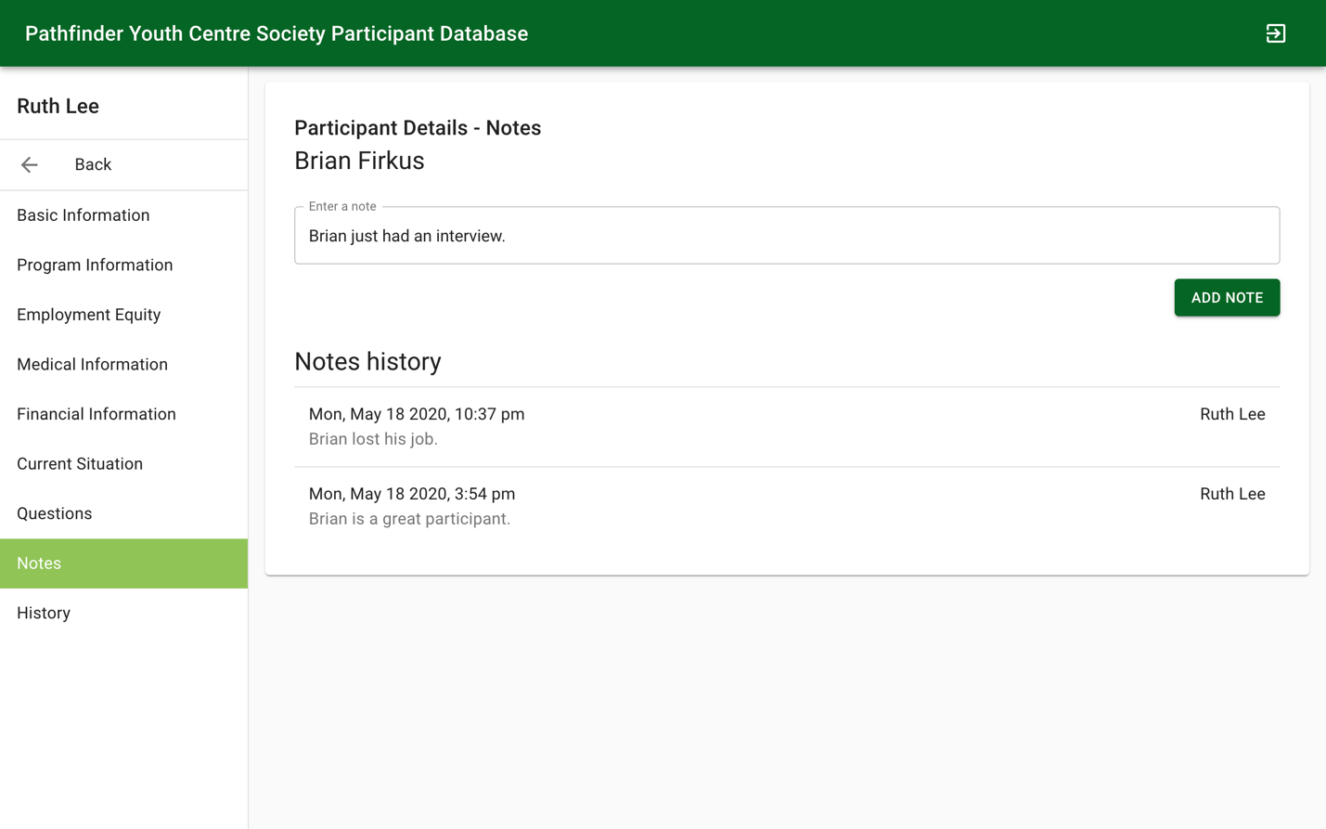

1

2

The components are as follows:

1. New note field
2. Notes history

Notes are ordered by the time they were added, with the newest notes at the top.

### Note History

An individual note in the note history looks like this:

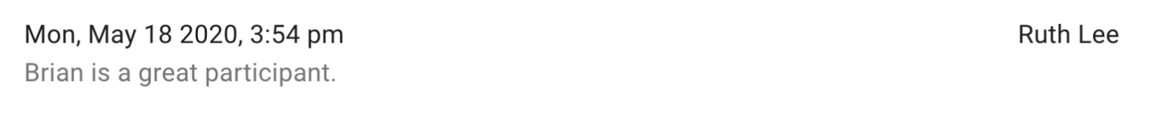

2

3

1

The components are as follows:

1. The time the note was written
2. The author of the note
3. The note content

### Adding a Note

To add a note, type the note into the *Enter a note* field and click *Add note*.

## Participant History

The history section contains a list of all updates made to a participant record, including record creation, updating fields, changing status, and moving from the new applications list to the participant database. Each history event lists what type of update it was, the user who made the update, and the time the update was made. If the update included changed field data, the history even lists what fields were changed as well as their values before and after the change.

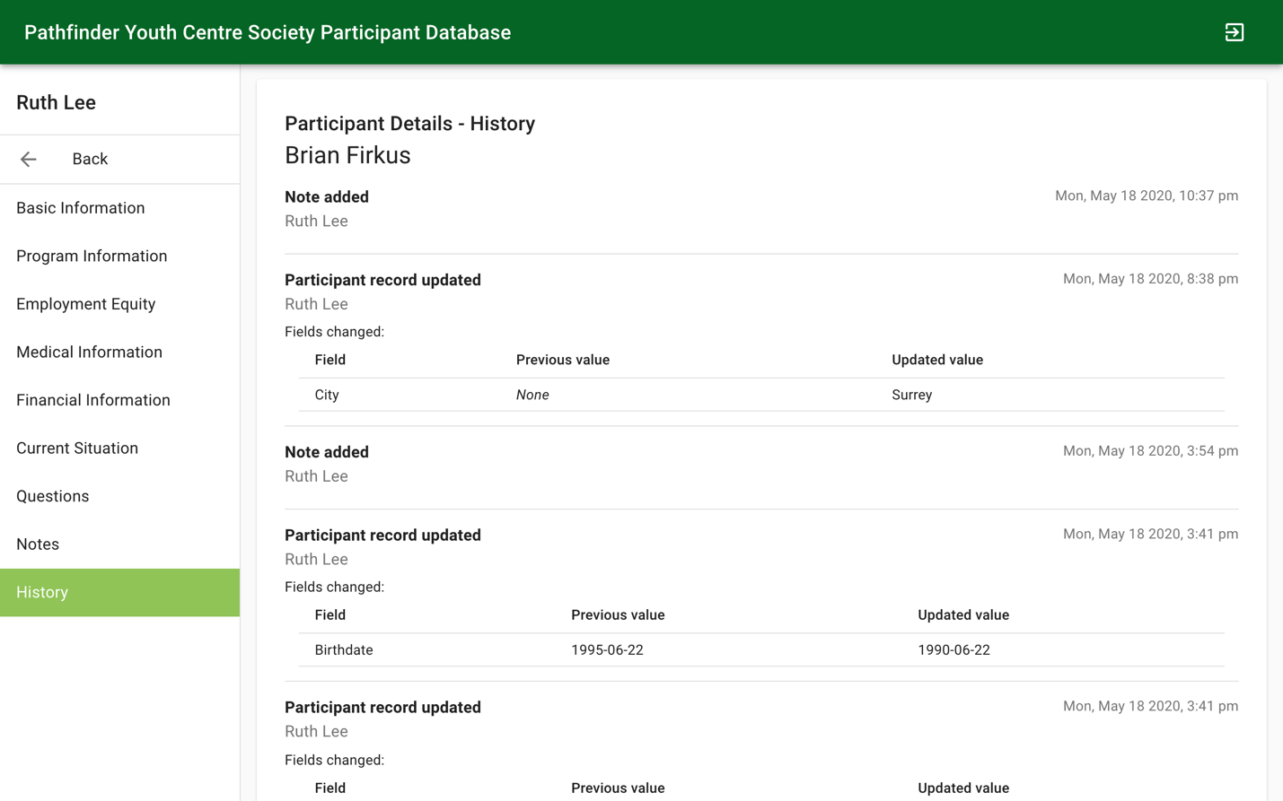

4

3

2

1

The components are as follows:

1. Update event description
2. Username of the staff member who made the update
3. Timestamp of the update
4. Updated fields

**Note:** If no fields were changed (e.g. if the update to the record was to add a note), the *Fields Changed* section will not appear on that history item.

Participant Record Actions – View mode  
The action buttons seen in the top right corner of the Participant Detail view will change depending on status the participant record has.

|  |  |
| --- | --- |
|  |  |
|  |  |

|  |  |
| --- | --- |
|  | Edit Changes the viewing mode from viewing to editing, allowing the user to update participant data. Participant records in any status except *Archived* can be edited. |
|  | Approve Prompts the user to enter the participant’s government-issued confirmation number and then changes the participant record to *Approved*status. Participant records in *Pending* or *Declined* status can be approved. |
|  | |
|  | Decline  Changes the participant record to *Declined* status. Participant records in *Pending* or *Approved* status can be declined. |
|  | Archive  Archives the participant record, separating it from the main list of active participants. The record can still be found by clicking on the *Archived* tab in the list view navigation drawer. Participant records in any status other than *New* and *Archived* can be archived. |
|  | Restore  Restores the archived participant record, returning it to the main list of active participants. Only Archived participant records can be restored. When the record is restored, its status changes to what it was before it was archived. |
|  | Delete Deletes a participant record forever. Only Archived records can be deleted. |
| **Warning:** If you delete a participant record, it cannot be recovered. | |

# Editing a participant record

Participant records with any status except for *Archived* can have their data updated. icon while in viewing mode to switch to editing mode.

3

2

1

The components are as follows:

1. Participant record navigation
2. Participant record fields
3. Participant record actions

Participant Record Actions – Edit mode  
While in editing mode, there are two actions that the user can take.

|  |  |
| --- | --- |
|  | Confirm Confirm editing and save any changes made to the participant record’s fields. |
| **Note:** Given name(s), last name, one method of contact (phone or email), date of birth, and social insurance number are all required fields and must have data in them in order to save the participant record.  A screenshot of a cell phone  Description automatically generated | |
|  | Cancel  Cancel editing and discard any changes made to the participant record. |

# Creating a participant record

To create a new participant record, clock on the + button in the bottom right corner of the list view.

This opens up the Create participant record interface.

2

3

1

The components are as follows:

1. Create record navigation
2. Create record fields
3. Create record actions

Participant Record Actions – Create mode  
While in participant record creation mode, there are two actions that the user can take.

|  |  |
| --- | --- |
|  | Confirm Confirm and create a new participant record, adding it to the database. The record is initially set to *Pending* status. |
| **Note:** Given name(s), last name, one method of contact (phone or email), date of birth, and social insurance number are all required fields and must have data in them in order to save the participant record. All other fields are optional. | |
|  | Cancel  Cancel participant record creation and return to the participant list view. |

# New Applications

When a potential participant submits a new application through the web form, you will be able to view it here. After ensuring a new application does not contain duplicate, spam, or otherwise invalid content, you can save it to the participant database.

The New Applications section of the navigation bar will show a badge indicating the number of new applications to be processed, if there are any.

The sort, search, and pagination functions for the New Applications list view work the same way as they do for the Participants List View (see details on page 5). There is no Add button on the New Applications page, as it is only for processing applications that come in through the web form. Participants that come in through other channels should be added from the main Participants screen.

## Processing a New Application

When you click on a new application’s entry in the table, you will see the new application detail page:

Much of the functionality on this page works like that of the Participant Detail View (see instructions on page 8). However, records in the New Application view cannot be approved, declined, or archived. The actions available for a new application are:

|  |  |
| --- | --- |
|  | Edit Changes the viewing mode from viewing to editing, allowing the user to edit the application (see the Edit section of Participant Detail View on page 12). |
|  | Accept and Save To ensure an applicant does not already exist in the main database, use the search function of the Participants page (see instructions on page 5) to search for the applicant’s SIN. If there are no results, the application can be processed. Click the Accept and Save button in the top right corner to save the application. The applicant will then appear in the Participants page with a Pending status. |
|  | Discard Submission  If an applicant already exists in the main database or if the application is spam or otherwise invalid, click the Discard Submission button. This will permanently delete the application. |
| **Warning:** If you discard an application, it cannot be recovered. | |

# Statistics

The statistics screen is where you can get details about participant demographics and barriers. When you first navigate to the page, you will see a count of total participants, as well as the number of new participants this month to date and this year to date.

3

1

2

The components are as follows:

1. Overall participant counts
2. Demographic selection
3. Refresh button

## Refreshing Statistics

The statistics view does not refresh automatically, as refreshing creates a lot of traffic on the database, which can lead to an increase in database costs. When you mouse over the refresh button, you can see the last time the statistics were updated.

When you click the refresh button, you will see a confirmation window appear, confirming that you want to refresh the data. This may take a few moments, especially as the size of the participant collection increases.

**Warning:** To avoid increasing database costs, it is not recommended to update statistics more than once per day.

## Saving Participant Data Locally

When you refresh the statistics, you will see a dialog asking if you would like to save a local copy of the database. If you select “yes,” you will download a CSV (comma-separated values) file containing all Participants that have Pending, Accepted, or Declined status. The CSV file can be opened in any spreadsheet program (e.g. Microsoft Excel).

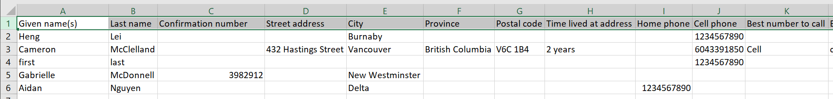

## Viewing Statistics by Demographic

To select a demographic to view statistics for, click the “Select Demographic” dropdown and select the demographic you want to view by. The information for that demographic will appear below the dropdown.

# Staff Management

Admin users can access the Staff Management page. From here, you can create, edit, and delete staff, as well as send staff a password reset email.

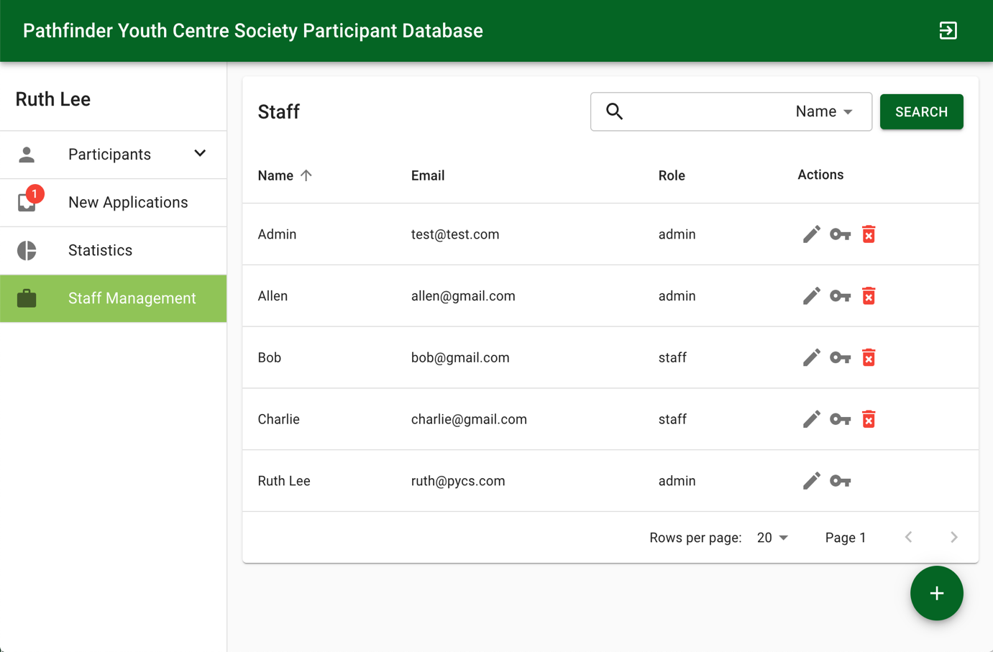

1

2

The components are as follows:

1. Add new user button
2. Actions for interacting with user entries (edit user account, send reset password email, delete user account)

The sort, search, and pagination functions for the New Applications list view work the same way as they do for the Participants List View (see details on page 5).

## User Actions

|  |  |
| --- | --- |
|  | Edit Edit the user’s name or role. You cannot change your own role. |
| **Note:** Email cannot be edited as it is used for user authentication. If you have entered the user’s email incorrectly, you must delete their account and create a new one. | |
|  | Reset Password  Send an email to the user with a link to reset the password for their account. |
|  | Delete Delete user, preventing them from logging into the database. You cannot delete your own account. |
| **Note:** In order to protect the security of the information in the database, it is important to delete user accounts for staff who no longer need access. | |

## User Roles

There are two roles available to assign to users: admin and staff. An admin user can access the Staff Management panel and create, modify, and delete users, as well as being able to access all other features of the application. A staff user can access all features except for Staff Management.

## Adding a New User

To add a new user, click on the + button in the bottom right corner of the page. A dialog will appear:

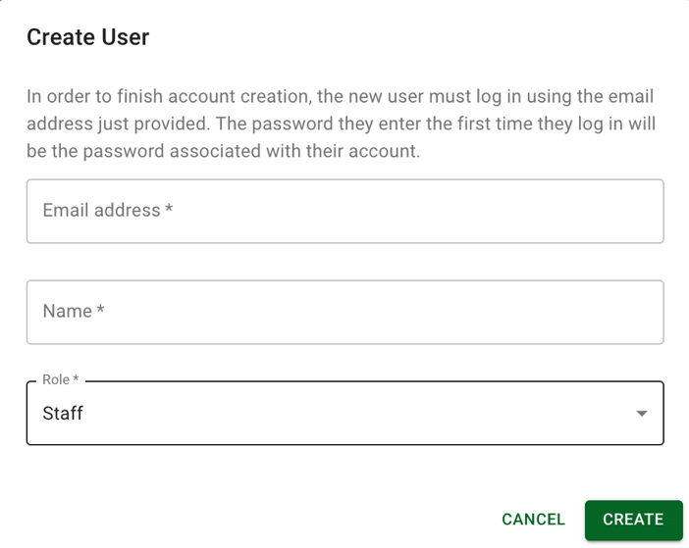

Enter the email address the user will use to sign in, as well as their name and whether they will be a Staff or Admin user, and then click Create.

**Note:** You cannot have two users with the same email address. If you attempt to create a user with an email address that already exists in the users list, you will see an error.

## Completing Enrollment

To complete enrollment, have the new user go to the login screen and sign in using their email address. The password they enter the first time they sign in will be the password for their account.

# Troubleshooting

|  |  |  |
| --- | --- | --- |
| **Problem** | **Possible Cause** | **Recommended Course of Action** |
| An alert message pops up every time you log in | You are using an obsolete browser | Update your browser or switch to a more modern one, like Chrome or Firefox. |
| Seeing error messages when trying to submit a form or save a record | Mandatory fields in the form have not been completed | Check the form again and ensure all mandatory fields are filled out. Fields with problems will be highlighted in red. Be sure to check other pages of the record if you don’t see the problems. |
| Statistics counts appear to exclude records | Some participants are archived or are still in New state | Archived records and new applications are not included in statistics counts. Any records you want included should be restored (if archived) or saved (if new). |
| You aren’t able to send a password recovery email | Signup was not completed or user’s email address is incorrect | Follow the steps for Completing Enrollment on page 21. If the email address is incorrect, delete the account and recreate it. No participant information is lost by deleting a user. |